Smokin’ Hot Bean Stew
Inspired by



DID YOU KNOW?
“CHIPOTLE PASTE!”

Ingredients
3 tortilla wraps
1 tin of mixed beans
1 red onion
2 bell peppers
4 garlic cloves
2 spring onions
1 tin of chopped tomatoes
1 tbsp of tomato puree
1 tsp Chipotle paste
2 tsp smoked paprika
1 vegetable stock
50g of Greek style salad cheese (or Feta)
1 tbsp lime juice
Nutrition – Total / Per Serving
Calories: ?kcal / ?kcal
Carbohydrates: ?g / ?g
Protein: ?g / ?g
Fat: ?g / ?g
Fibre: ?g / ?g
Sugar: ?g / ?g






Star Rating:

Good for:



Method
Step 1 - Preparation
Preheat the oven to 200°C.
Thinly slice the red onion, garlic, spring onions and bell peppers.
Drain and rinse the mixed beans.
Cut the tortilla wraps into triangles.




Step 2 – Roast & Stew
Place the bell peppers onto a baking tray, drizzle with oil and season with salt & pepper.
Place in the oven to roast ~15-18 mins.

Heat some oil in a saucepan, add the red onion and cook until soft (~4 mins). Add the garlic, chipotle paste, tomato puree, and smoked paprika; mix well before adding in the chopped tomatoes, mixed beans, and vegetable stock paste.
Reduce heat and let simmer for ~10min.
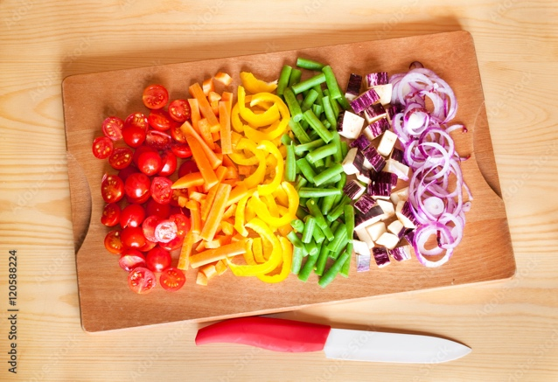
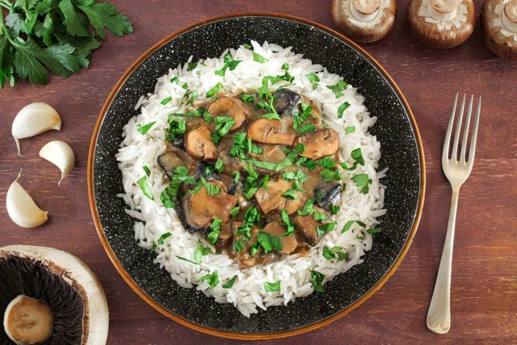
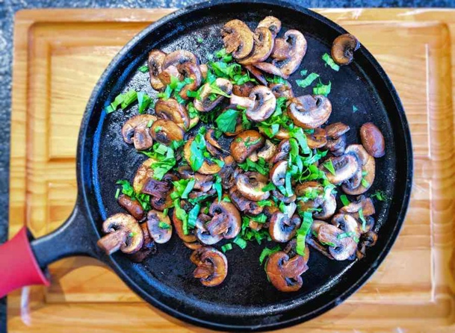
Step 4 – Bring it Together
Divide the stew between bowls, top with the Greek style salad cheese and spring onions.

Take the tortilla triangles out of the oven and place alongside the stew.

Enjoy!
Step 3 – Finishing Touches
On a separate baking tray, add your tortilla triangles.
Season with salt and place in the oven until crispy and golden (~5 mins).

When the peppers are roasted, add them to your saucepan.
Add in the lime juice and mix to combine.

Crumble (or chop) your Greek style salad cheese into small pieces.

